16.69: a) the frequency with which the sound waves both strike and are reflected from the insect. The frequencies at which the bat sends and receives the signals are related by
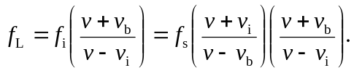
Solving for 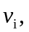
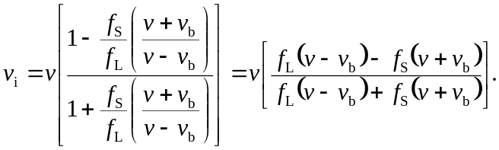
Letting 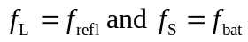 gives the result.
b) If

